Template & Instructions for Preparing Digests for the Award for Encouragement of Research in the 34th Annual Meeting (Bold, 14 points)

P. Yokohama*^{,1)} and Z. Yokohama²⁾ (12 points)
¹⁾ Affiliations and address ..... (11 points),
²⁾ Affiliations and address ..... (11 points)

Keywords: innovation, material, science, technology (12 points)
Corresponding author*: xxxxx@xxx.xxx.xx.xx (12 points)

Abstract
The manuscript (Digest) for the Award for Encouragement of Research in the Annual Meeting of MRS-J should be written in English and submitted in PDF format. The instructions below must be followed by all candidates submitting Digests for the nomination of the Award for Encouragement of Research in the Annual Meeting of MRS-J. The maximum length of the Digest is limited to 2 pages, and the file size should be less than 10MB. The Digests submitted by the selected candidates as the Award winners will be published in the MRS-J Bulletin and delivered to all MRS-J members as Online Journal. MRS-J does not claim copyrights for the Digests and selected candidates can submit their full papers to academic journals using the text, figures and tables in the Digests.

1. Introduction
The manuscript is to be typed using Serif (Roman) typefaces, such as Times New Roman (or equivalent). The size for the title is 14pt and the size for the author’s name is 12pt. Leave one blank line between the title and the author’s name. Underline the name of the candidate who shall deliver a presentation in the Annual Meeting. The name of the corresponding author of the Digest should be noted with an asterisk.

2. Experiment (or Theory)
The author’s affiliation(s) should immediately follow the author’s name, in 10pt size. All other parts of the text are to be typed in 12pt size. Leave one blank line before starting the text (the abstract and main body of the manuscript). Keywords and the email address of the corresponding author are to be written after the affiliation.
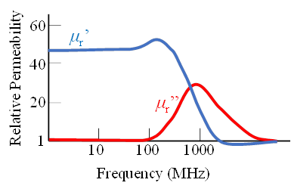
Fig.1 Figure caption (10 points)

3. Results and discussion
It is highly recommended that tables and/or figures should be included in the Digest. Place the table caption over the table. Use Roman numerals (Table I, Table II, etc.) for the table number, and upper- and lowercase letters for the caption. Allow a blank line after each table before you resume typing text.

3.1 Subheadings
All figures (line drawings and photographs) must be reduced to the appropriate size and positioned in place. Center the drawing above the caption and number all figures using Arabic numbers (Fig.1, Fig.2, etc.). Center the photograph above the caption. Color illustrations, photographs, and figures are acceptable.

4. Conclusions (or Summary)
A manuscript that does not follow these instructions will not be forwarded to the reviewing process. The Digest in PDF format should be submitted by the deadline of the abstract submission for the symposia and/or in the forums of the Annual Meeting of MRS-J, through the Annual Meeting homepage.

Acknowledgments (OPTIONAL)

References
- A. B. Yokohama and C. D. Kanagawa, MRS-J Bulletin., 1, 100-105 (2020). DOI: https://doi.org/10.15000/mrsjb.01.100
2) E. Yokohama, “Material Researches”, Ed. by F. G. Yokohama, MRS-J press, Yokohama (2020) pp. 500-550. DOI: https://doi.org/10.14723/tmrsj.50.00

